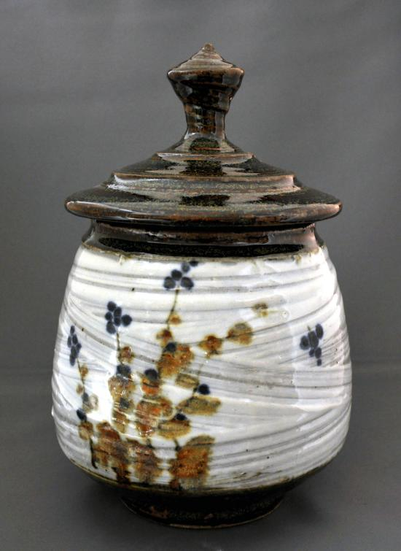  “Lidded Jar with Blue Florals”  John Jessiman | Studio in Ceramics  Mrs. Pountain  Student Expectations  lpountain@newpaltz.k12.ny.us  256-4175 ext. 69541  “The hands make the head clever.”  ~ Michael Cardew, Potter

The word Ceramics comes from the Greek keramos, and refers to the art of making both useful and beautiful objects and artifacts such as bowls, sculpture, cooking and serving utensils, tiles, electric insulators, components of spaceships, bricks, and many other objects used by humans. In this course students will develop an understanding of the nature of clay and the properties of ceramic materials.

As a student in this class you are expected to:
- Arrive to class on time.
- Be prepared for class with all necessary tools for the current project. (A pencil and sketchbook are required every day.)
- Be responsible for the care and maintenance of all equipment, tools and the classroom as a whole.
- Participate in loading and unloading the kiln on a regular basis.
- Complete all class assignments as well as homework on time. Lateness will be penalized. (Absence or special circumstances will be discussed on an individual basis with me.)
- Use Open Studio Hours. Your ongoing homework assignment is to come to Open Studio on Tuesdays after school if you run out of class time or miss.
- Use class time to its fullest extent, as well as participate in discussions and critiques.
- Make use of library and classroom resources in conjunction with various projects.
- RESPECT YOURSELF, YOUR CLASSMATES, AND YOUR TEACHER!
- THINK! Do not be afraid to “think outside the box”.
Grades:
Your grade for this class will be based on participation, creativity, class work, effort, neatness, and the overall quality of work. Rubrics are used to arrive at project grades. They may change depending on the criteria of a particular assignment, but the main categories are generally; Composition, Creativity, Effort and Craftsmanship.

You will be expected to hand in a digital portfolio at the end of each quarter. This will be a visual record of all your finished work. You will be given a cover sheet, which will list all work that is due.

Sketchbook and Homework:
You will need to keep a sketchbook for this class. In it you will keep all class notes, homework assignments, research and rough sketches of your projects. You will have assignments which will be designed to encourage creative thinking. This book should be one that is bound and will not easily fall apart.

Supplies:
The majority of the things you need for this class will be provided for you. In addition to your sketchbook you may want to bring in:
- A smock, apron or old tee shirt
- Plastic bags – dry cleaner bags work the best
- Hand lotion

Course Outline:
Areas of study and exploration in this course will include but are not limited to:
-The nature of clay
-Glazing and finishing techniques
-Firing techniques – electric and primitive
-Studio equipment
-The history of ceramics

Ceramic construction and processes including:
-Three-dimensional design
-Wedging
-Decoration and texture techniques
-Pinch and Modeling Methods
-Coil Building
-Slab Construction
-Drape and Press molds
-Throwing on the wheel
-Sculptural Construction

These are just some of the things we will do this year. Please know that I am open to your suggestions. If there is something you would like to learn about that is not listed above, let me know and I will try to incorporate it into the curriculum.

